UNITED STATES

SECURITIES AND EXCHANGE COMMISSION
Washington, D.C. 20549

FORM 6-K

REPORT OF FOREIGN PRIVATE ISSUER

PURSUANT TO RULE 13a-16 OR 15d-16

UNDER THE SECURITIES EXCHANGE ACT OF 1934

For the month of April 2026

Commission File Number: 001-36397

Weibo Corporation

(Registrant’s Name)

8/F, QIHAO Plaza, No. 8 Xinyuan S. Road

Chaoyang District, Beijing 100027

People’s Republic of China

(Address of Principal Executive Offices)

Indicate by check mark whether the registrant files or will file annual reports under cover Form 20-F or Form 40-F.

Form 20-F ☒ Form 40-F ☐

EXHIBIT INDEX

Exhibit 99.1 — Press Release

Exhibit 99.2 — Notice of Annual General Meeting

Exhibit 99.3 — Proxy Card for Annual General Meeting

Exhibit 99.4 — Voting Card for ADS Holder

Exhibit 99.5 — Announcement — Record Date

2

SIGNATURE

Pursuant to the requirements of the Securities Exchange Act of 1934, the registrant has duly caused this report to be signed on its behalf by the undersigned, thereunto duly authorized.

 | WEIBO CORPORATION
Date: April 13, 2026 | By: /s/ Fei Cao
 |  | Fei Cao
 |  | Chief Financial Officer
 | 3

Exhibit 99.1

Weibo to Hold Annual General Meeting on May 27, 2026

BEIJING, April 13, 2026 -- Weibo Corporation (the “Weibo” or “Company”) (Nasdaq: WB and HKEX: 9898), a leading social media in China, today published a notice to announce that it will hold an annual general meeting (the “AGM”) of shareholders (the “Notice of AGM”) at 5809-5810, Two International Finance Centre, 8th Finance Street, Central, Hong Kong on Wednesday, May 27, 2026 at 2:30 p.m. (Hong Kong time), for the purposes of considering and, if thought fit, passing the proposed resolutions set forth in the Notice of AGM. The Notice of AGM and proxy card for the AGM are available on the Company’s website at ir.weibo.com. The board of directors of Weibo fully supports the proposed resolutions listed in the Notice of AGM and recommends that shareholders and holders of ADSs vote in favor of the resolutions set out in the Notice of AGM.

Holders of record of Class A ordinary shares of the Company (the “Class A Ordinary Shares”) and Class B ordinary shares of the Company at the close of business on April 27, 2026, Hong Kong time, are entitled to attend and vote at the AGM and any adjourned meeting thereof. Holders of record of American Depositary Shares (the “ADSs”) as of the close of business on April 27, 2026, New York time, who wish to exercise their voting rights for the underlying Class A Ordinary Shares must give voting instructions to JPMorgan Chase Bank, N.A., the depositary of the ADSs.

Weibo’s Form 20-F can be accessed on the Company’s website at ir.weibo.com, as well as on the SEC’s website at http://www.sec.gov.

About Weibo

Weibo is a leading social media for people to create, share and discover content online. Weibo combines the means of public self-expression in real time with a powerful platform for social interaction, content aggregation and content distribution. Any user can create and post a feed and attach multi-media and long-form content. User relationships on Weibo may be asymmetric; any user can follow any other user and add comments to a feed while reposting. This simple, asymmetric and distributed nature of Weibo allows an original feed to become a live viral conversation stream.

Weibo enables its advertising and marketing customers to promote their brands, products and services to users. Weibo offers a wide range of advertising and marketing solutions to companies of all sizes. Weibo generates a substantial majority of its revenues from the sale of advertising and marketing services, including the sale of social display advertisement and promoted marketing offerings. Weibo displays content in a simple information feed format and offers native advertisement that conform to the information feed on our platform. We are continuously refining our social interest graph recommendation engine, which enables our customers to perform people marketing and target audiences based on user demographics, social relationships, interests and behaviors, to achieve greater relevance, engagement and marketing effectiveness.

Safe Harbor Statement

This press release contains forward-looking statements. These statements are made under the "safe harbor" provisions of the U.S. Private Securities Litigation Reform Act of 1995. These forward-looking statements can be identified by terminology, such as "will," "expects," "anticipates," "future," "intends," "plans," "believes," "confidence," "estimates" and similar statements. Weibo may also make written or oral forward-looking statements in the Company's periodic reports to the U.S. Securities and Exchange Commission ("SEC"), in announcements, circulars or other publications made on the website of The Stock Exchange of Hong Kong Limited (the "Hong Kong Stock Exchange"), in press releases and other written materials and in oral statements made by its officers, directors or employees to third parties. Statements that are not historical facts, including statements about the Company's beliefs and expectations, are forward-looking statements. Forward-looking statements involve inherent risks and uncertainties. A number of important factors could cause actual results to differ materially from those contained in any forward-looking statement. Potential risks and uncertainties include, but are not limited to, Weibo's limited operating history in certain new businesses; failure to sustain or grow active user base and the level of user engagement; the uncertain regulatory landscape in China; fluctuations in the Company's quarterly operating results; the Company's reliance on advertising and marketing sales for a majority of its revenues; failure to successfully develop, introduce, drive adoption of or monetize new features and products; failure to compete effectively for advertising and marketing spending; failure to successfully integrate acquired businesses; risks associated with the Company's investments, including equity pick-up and impairment; failure to compete successfully against new entrants and established industry competitors; changes in the macro-economic environment, including the depreciation of the Renminbi; and adverse changes in economic and political policies of the PRC government and its impact on the Chinese economy. Further information regarding these and other risks is included in Weibo's annual reports on Form 20-F and other filings with the SEC and the Hong Kong Stock Exchange. All information provided in this press release is current as of the date hereof, and Weibo assumes no obligation to update such information, except as required under applicable law.

Contacts

Investors Relations

Weibo Corporation

Tel: +86-10-5898-3336

Email: ir@staff.weibo.com

2

Exhibit 99.2

WEIBO CORPORATION

(A company controlled through weighted voting rights and incorporated in the Cayman Islands with limited liability)

(NASDAQ: WB and HKEX: 9898)

NOTICE OF ANNUAL GENERAL MEETING OF SHAREHOLDERS

To Be Held on May 27, 2026

(or any adjourned or postponed meeting thereof)

Notice is hereby given that Weibo Corporation, a Cayman Islands company (the “Company”), will hold its annual general meeting (the “AGM”) of shareholders at 5809-5810, Two International Finance Centre, 8th Finance Street, Central, Hong Kong on Wednesday, May 27, 2026. The meeting will begin at 2:30 p.m.. (Hong Kong time). At the AGM, following resolutions will be considered, and if thought fit, passed as the following resolutions (the “Proposed Resolutions”):

- as an ordinary resolution, THAT Mr. Charles Guowei Chao shall be re-elected as a director of the Company at this annual general meeting and retain office until his retirement pursuant to the Company’s memorandum and articles of association;
- as an ordinary resolution, THAT Mr. Gaofei Wang shall be re-elected as a director of the Company at this annual general meeting and retain office until his retirement pursuant to the Company’s memorandum and articles of association; and
- as an ordinary resolution, THAT Mr. Pochin Christopher Lu shall be re-elected as a director of the Company at this annual general meeting and retain office until his retirement pursuant to the Company’s memorandum and articles of association.

In addition, the meeting will transact any other business properly brought before the meeting.

Certain biographic information of Mr. Charles Guowei Chao, Mr. Gaofei Wang and Mr. Pochin Christopher Lu is set out in Appendix I hereto.

SHARES RECORD DATE AND ADS RECORD DATE

The Board of Directors of the Company has fixed the close of business on April 27, 2026 Hong Kong time, as the record date (the “Shares Record Date”) of our Class A ordinary shares with a par value of US$0.00025 each (the “Class A Ordinary Shares”) and Class B ordinary shares with a par value of US$0.00025 each (the “Class B Ordinary Shares,” and together with the Class A Ordinary Shares, the “Shares”).

Holders of record of the Company’s Shares as of the Shares Record Date are entitled to attend and vote at the AGM and any adjourned meeting thereof. Holders of record of American Depositary Shares (the “ADSs”) as of the close of business on April 27, 2026 New York time (the “ADS Record Date”) who wish to exercise their voting rights for the underlying Class A Ordinary Shares must give voting instructions to JPMorgan Chase Bank, N.A., the depositary of the ADSs.

ATTENDING THE AGM

Only holders of record of Shares as of the Shares Record Date are entitled to attend and vote at the AGM. Please note that holders of ADSs are not entitled to attend the AGM. Any ADS holder who appears at the venue of the AGM will not be allowed to attend the AGM. Holders of ADSs who wish to exercise their voting rights for the underlying Shares must act through the depositary of the company’s ADS program, JPMorgan Chase Bank, N.A.

All officers and agents of the Company reserve the right to refuse any person entry to the AGM venue, or to instruct any person to leave the AGM venue, where such officer or agent reasonably considers that such refusal or instruction is or may be required for the Company or any other person to be able to comply with applicable laws and regulations. The exercise of such right to refuse entry or instruct to leave shall not invalidate the proceedings at the AGM.

PROXY FORMS AND ADS VOTING CARDS

A holder of Shares as of the Shares Record Date may appoint a proxy to exercise his or her rights at the AGM. A holder of ADSs as of the ADS Record Date will need to instruct JPMorgan Chase Bank, N.A., the depositary of the ADSs, as to how to vote the Class A Ordinary Shares represented by the ADSs. Please refer to the proxy form (for holders of Shares) or ADS voting card (for holders of ADSs), which are incorporated by reference into and as a part of this notice, and also the proxy statement for further details and instructions. The proxy statement and the proxy form are also available for viewing on our website at http://ir.weibo.com.

Shareholders registered in the Company’s register of members at the close of business on the Shares Record Date are cordially invited to attend the AGM in person. Your vote is important. You are urged to complete, sign, date and return the proxy form to the Company’s Hong Kong branch share registrar and transfer office, Computershare Hong Kong Investor Services Limited (“Computershare”) (for holders of Shares) or your voting instructions to JPMorgan Chase Bank, N.A. (for holders of the ADSs) as promptly as possible and before the prescribed deadline if you wish to exercise your voting rights. Computershare must receive the proxy form by no later than 48 hours before the time of the AGM at 17M Floor, Hopewell Centre, 183 Queen’s Road East, Hong Kong to ensure your representation at the AGM, and JPMorgan Chase Bank, N.A. must receive your voting instructions before 9:00 a.m. (Eastern Time), May 19, 2026 to enable the votes attaching to the Class A Ordinary Shares represented by your ADSs to be cast at the AGM. Where the chairman of the AGM acts as proxy and is entitled to exercise his discretion, he is likely to vote the shares FOR the resolutions. If you change your mind after you return your proxy form, you may revoke your proxy by voting in person at the AGM, or by submitting a notice of revocation of another proxy form with a later date up to 48 hours before the AGM or later at the discretion of the Chairman of the AGM.

ANNUAL REPORT

Shareholders may obtain a copy of the Company’s annual report, free of charge, from the Company’s website at ir.weibo.com, the HKEX’s website at www.hkexnews.hk or from the SEC’s website at www.sec.gov. or by contacting Investor Relations Department, Weibo Corporation, 8/F, QIHAO Plaza, No. 8 Xinyuan S. Road, Chaoyang District, Beijing 100027, People’s Republic of China, telephone +86 10 5898-3336.

By Order of the Board of Directors,

Charles Guowei Chao

Chairman of the Board of Directors

Beijing, China

April 13, 2026

APPENDIX I

BIOGRAPHIC INFORMATION OF THE

RETIRING DIRECTOR STANDING FOR RE-ELECTION

Certain biographic information of the retiring directors is set forth below:

Charles Guowei Chao has served as our Chairman of the board of directors since our inception. He has served as Chairman of the board of directors of SINA from August 2012 to March 2021 and continues to serve as the director of SINA since March 2021. He has been SINA’s Chief Executive Officer since May 2006. He served as SINA’s President from September 2005 to February 2013, Chief Financial Officer from February 2001 to May 2006, Co-Chief Operating Officer from July 2004 to September 2005. Prior to joining SINA, Mr. Chao served as an audit manager at PricewaterhouseCoopers, LLP. Prior to that, Mr. Chao was a news correspondent at Shanghai Media Group. Mr. Chao holds a B.A. in Journalism from Fudan University in Shanghai, China, an M.A. degree from the University of Oklahoma and a Master of Professional Accounting degree from the University of Texas at Austin.

Gaofei Wang has served as our Chief Executive Officer since February 2014 and our director since August 2020. Since our inception, Mr. Wang has had various product and business development roles at Weibo and was promoted to General Manager in December 2012. Mr. Wang joined SINA in August 2000 and worked in the product development department until early 2004 when he transferred to the SINA Mobile division. He served as General Manager of SINA Mobile division from November 2006 to November 2012. Mr. Wang has served as an independent non-executive director of a Hong Kong Stock Exchange-listed company, Distinct Healthcare Holdings Limited (HKEX: 02677), since February 2026. Mr. Wang has been a director of DiDi Global Inc. since June 2021. Mr. Wang holds a B.S. degree in Computer Science from Peking University and an EMBA degree from Guanghua School of Management of Peking University.

Pochin Christopher Lu has served as our independent director since August 2020. Mr. Lu has served as the Executive Director at Foxconn Interconnect Technology Ltd., a company listed on the Hong Kong Stock Exchange (HKEX: 6088) and global leader in the supply of precision components, since March 16, 2015. Mr. Lu is also the Global Cooperating Officer and Chief Financial Officer of Foxconn Interconnect Technology Ltd. From January 1981 to December 2014, Mr. Lu served multiple executive positions at Deloitte Touche Tohmatsu Limited, including the Chief Executive Officer of Deloitte China and a member of the Deloitte Touche Tohmatsu Limited Global Executive Committee. Mr. Lu is an independent non-executive director at Honma Golf Limited, a Hong Kong Stock Exchange-listed company (HKEX: 6858) that manufactures and distributes golf products. He is a member of the American Institute of Certified Public Accountants and the Chinese Institute of Certified Public Accountants. Mr. Lu obtained a Bachelor of Science degree in accounting and a master of accounting science degree from the University of Illinois at Urbana-Champaign, USA, in 1980 and 1981, respectively.

Exhibit 99.3

WEIBO CORPORATION

(Incorporated in the Cayman Islands with limited liability)

(NASDAQ: WB and HKEX: 9898)

Proxy Form for Annual General Meeting (or any adjournment thereof) to be held

at 5809-5810, Two International Finance Centre, 8th Finance Street, Central, Hong Kong on

May 27, 2026 at 2:30 p.m. (Hong Kong time)

Introduction

This form of proxy (the “Form of Proxy”) is furnished in connection with the solicitation by the board of directors of Weibo Corporation (the “Board”), a Cayman Islands company (the “Company”), of proxies from the holders of the issued and outstanding Class A ordinary shares and Class B ordinary shares, par value US$0.00025 per share, of the Company (collectively, the “Ordinary Shares”) to be exercised at the annual general meeting of the Company (the “AGM”) to be held at 5809-5810, Two International Finance Centre, 8th Finance Street, Central, Hong Kong, People’s Republic of China on May 27, 2026 at 2:30 p.m. (Hong Kong time), and at any adjourned or postponed meeting thereof, for the purposes set forth in the accompanying notice of the AGM (the “AGM Notice”).

Only the holders of record of the Ordinary Shares on the Company’s register of members at the close of business on April 27, 2026 (Hong Kong time) (the “Record Date”) are entitled to receive notice of and to vote at the AGM. In respect of the matters requiring shareholders’ vote at the AGM, each Class A Ordinary Share is entitled to one vote and each Class B Ordinary Share is entitled to three votes. The quorum of for a general meeting is one or more members (or in the case of a member being a corporation, by its duly authorized representative) together holding (or representing by proxy) at the date of the relevant meeting not less than 10% of all votes attaching to all shares present in person or by proxy, which carry the right to vote at general meetings.

This Form of Proxy and the accompanying AGM Notice will be first mailed to the shareholders of the Company on or about May 5, 2026. A proxy need not be a shareholder of the Company. A shareholder entitled to attend and vote at the AGM is entitled to appoint one or more proxies to attend and vote in his/her stead. The Ordinary Shares represented by all properly executed proxies returned to the Company will be voted at the AGM as indicated or, if no instruction is given, the holder of the proxy will vote the shares in his discretion, unless a reference to the holder of the proxy having such discretion has been deleted and initialed on this Form of Proxy. Where the chairperson of the AGM acts as proxy and is entitled to exercise his discretion, he or she is likely to vote the shares FOR the resolutions. As to any other business that may properly come before the AGM, all properly executed proxies will be voted by the persons named therein in accordance with their discretion. The Company does not presently know of any other business which may come before the AGM. However, if any other matter properly comes before the AGM, or any adjourned or postponed meeting thereof, which may properly be acted upon, unless otherwise indicated the proxies solicited hereby will be voted on such matter in accordance with the discretion of the proxy holders named therein. Any person giving a proxy has the right to revoke it at any time before it is exercised (i) by filing with the Company, at the address set forth below, a duly signed revocation, or (ii) by voting in person at the AGM.

To be valid, this Form of Proxy must be completed, signed and returned to the Company’s Hong Kong branch share registrar and transfer office, Computershare Hong Kong Investor Services Limited at 17M Floor, Hopewell Centre, 183 Queen’s Road East, Hong Kong as soon as possible so that it is received by the Company no later than 48 hours before the time of the AGM.

WEIBO CORPORATION

(Incorporated in the Cayman Islands with limited liability)

(NASDAQ: WB and HKEX: 9898)

Proxy Form for Annual General Meeting (or any adjournment thereof) to be held at 5809-5810, Two International Finance Centre, 8th Finance Street, Central, Hong Kong on May 27, 2026 at 2:30 p.m. (Hong Kong time)

I/We, ___________________________________________________________________________________________________________

Please Print Name(s)

of _____________________________________________________________________________________________________________________

Please Print Address(es)

the undersigned, being the registered holder(s) of _____________________ Class A ordinary shares ^{(Note 1)}, par value US$0.00025 per share, of Weibo Corporation
(the “Company”) and _____________________ Class B ordinary shares ^{(Note 1)}, par value US$0.00025 per share, of the Company, hereby appoint the Chairman of the
Annual General Meeting^{(Note} ²⁾ or _____________________________________________________________ of

_________________________________________________________________________________________________________________________

as my/our proxy to attend and act for me/us at the Annual General Meeting (the “AGM”) and at any adjournment(s) or postponement(s) thereof, and in the event of a poll voting, to vote for me/us as indicated below, or if no such indication is given, as my/our proxy thinks fit.

 | PROPOSALS | FOR | AGAINST | ABSTAIN
 | PROPOSALS | (Note 3) | (Note 3) | (Note 3)
1. | As an ordinary resolution: | ☐ | ☐ | ☐
 | THAT Mr. Charles Guowei Chao shall be re-elected as a director of the Company at this
 | annual general meeting and retain office until his retirement pursuant to the Company’s
 | memorandum and articles of association.
2. | As an ordinary resolution: | ☐ | ☐ | ☐
 | THAT Mr. Gaofei Wang shall be re-elected as a director of the Company at this annual
 | general meeting and retain office until his retirement pursuant to the Company’s
 | memorandum and articles of association.
3. | As an ordinary resolution: | ☐ | ☐ | ☐
 | THAT Mr. Pochin Christopher Lu shall be re-elected as a director of the Company at this
 | annual general meeting and retain office until his retirement pursuant to the Company’s
 | memorandum and articles of association.

Dated _________________, 2026 Signature(s) ^{(Note 4)}___________________________________

- Please insert the number of or strike out the class of shares registered in your name(s) to which this proxy relates. If no number is inserted, this proxy form will be deemed to relate to all the shares in the Company registered in your name(s).

- If any proxy other than the Chairman is preferred, strike out the words “THE CHAIRMAN OF THE ANNUAL GENERAL MEETING OR” and insert the name and address of the proxy desired in the space provided. A member may appoint one or more proxies to attend and vote in his or her stead. ANY ALTERATION MADE TO THIS PROXY FORM MUST BE INITIALED BY THE PERSON(S) WHO SIGN(S) IT.

- IMPORTANT: IF YOU WISH TO VOTE FOR THE RESOLUTION, TICK THE APPROPRIATE BOX MARKED “FOR.” IF YOU WISH TO VOTE AGAINST THE RESOLUTION, TICK THE APPROPRIATE BOX MARKED “AGAINST.” IF YOU WISH TO ABSTAIN FROM VOTING ON A PARTICULAR RESOLUTION, TICK THE APPROPRIATE BOX MARKED “ABSTAIN.” Failure to complete any or all the boxes will entitle your proxy to cast his or her votes at his or her discretion.

- This proxy form must be signed by you or your attorney duly authorized in writing or, in the case of a corporation, must be executed under the hand of an officer or attorney duly authorized to sign the same.

Exhibit 99.4
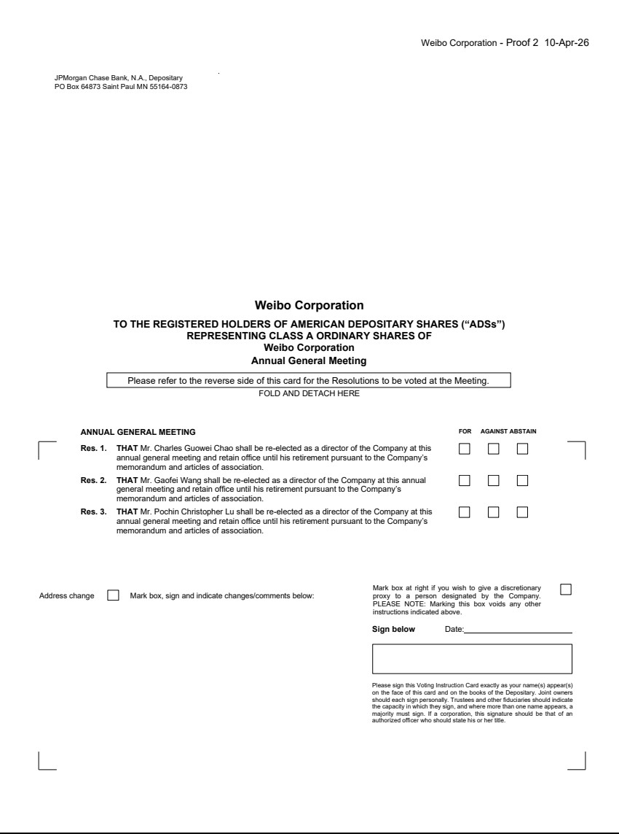

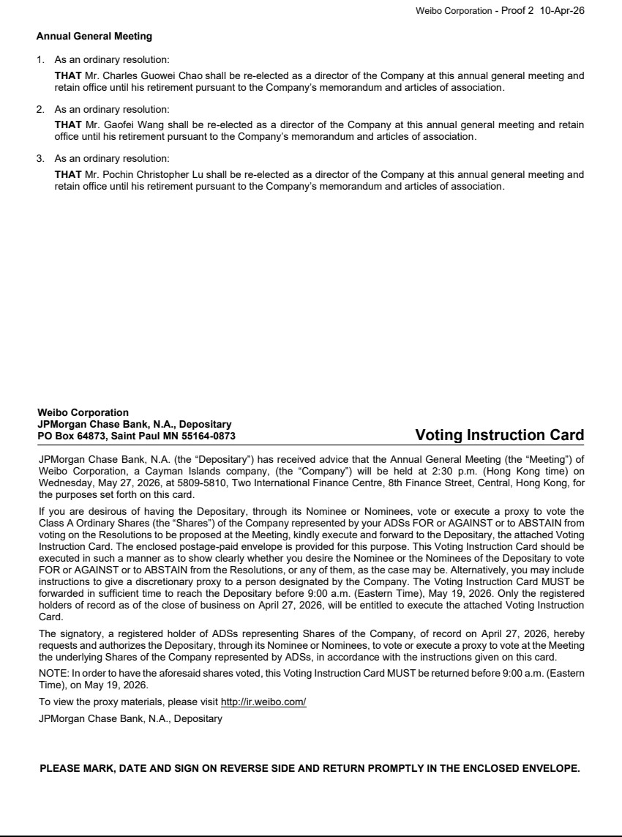

Exhibit 99.5

Hong Kong Exchanges and Clearing Limited and The Stock Exchange of Hong Kong Limited take no responsibility for the contents of this announcement, make no representation as to its accuracy or completeness and expressly disclaim any liability whatsoever for any loss howsoever arising from or in reliance upon the whole or any part of the contents of this announcement.


Weibo Corporation

微 博 股 份 有 限 公 司

(A company controlled through weighted voting rights and incorporated in the Cayman Islands with limited liability)

(Stock Code: 9898)

RECORD DATE FOR

ANNUAL GENERAL MEETING OF SHAREHOLDER

Please note that the record date for determining the eligibility of the holders of our Class A ordinary shares with a par value of US$0.00025 each (the “Class A Ordinary Shares”) and Class B ordinary shares with a par value of US$0.00025 each (the “Class B Ordinary Shares”, and together with the Class A Ordinary Shares, the “Shares”), to attend and vote at our forthcoming annual general meeting of shareholders (the “General Meeting”) will be as of close of business on Monday, April 27, 2026 (Hong Kong time) (the “Shares Record Date”). In order to be eligible to attend and vote at the General Meeting, all valid documents for the transfers of shares accompanied by the relevant share certificates must be lodged with the Company’s Hong Kong branch share registrar and transfer office, Computershare Hong Kong Investor Services Limited, 17M Floor, Hopewell Centre, 183 Queen’s Road East, Hong Kong, no later than 4:30 p.m. on Monday, April 27, 2026 (Hong Kong time). All persons who are registered holders of the Shares on the Shares Record Date will be entitled to attend and vote at the General Meeting.

Holders of American depositary shares (the “ADSs”), representing the Class A Ordinary Shares of the Company, as of close of business on Monday, April 27, 2026 (New York time) (the “ADSs Record Date”, together with the Shares Record Date, the “Record Date”), will be able to instruct JPMorgan Chase Bank, N.A., as depositary of the ADSs (the “Depositary”), as to how to vote the Class A Ordinary Shares represented by such ADSs. Upon the timely receipt of a properly completed ADS voting instruction card, the Depositary will endeavour, to the extent practicable and legally permissible, to vote or cause to be voted at the General Meeting the amount of Class A Ordinary Shares represented by the ADSs in accordance with the instructions set forth in the ADS voting instruction card. Please be aware that, due to the time difference between Hong Kong and New York, if a holder of ADSs cancels his/her ADSs in exchange for Class A Ordinary Shares on Monday, April 27, 2026 (New York time), such holder of ADSs will not be able to instruct the Depositary as to how to vote the Class A Ordinary Shares represented by the cancelled ADSs as described above, and will also not be a holder of those Class A Ordinary Shares as of the Shares Record Date for the purpose of determining the eligibility to attend and vote at the General Meeting.

1

Details including the date and location of our General Meeting will be set out in our notice of General Meeting to be issued and provided to holders of our Shares and ADSs as of the respective Record Date together with the proxy materials in due course.

By order of the Board

Weibo Corporation

Mr. Charles Guowei Chao

Chairman of the Board

Hong Kong, April 13, 2026

As at the date of this announcement, the board of directors of the Company comprises Mr. Charles Guowei Chao, Mr. Gaofei Wang, Ms. Hong Du and Mr. Bo Liu, as the directors, and Mr. Pochin Christopher Lu, Mr. Pehong Chen and Mr. Yan Wang as the independent directors.

2

